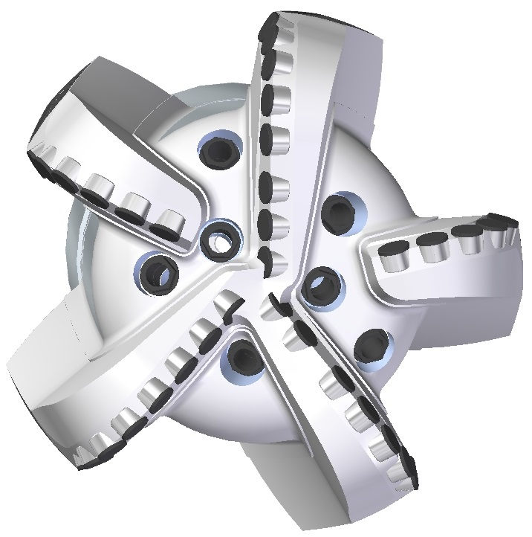 |  | 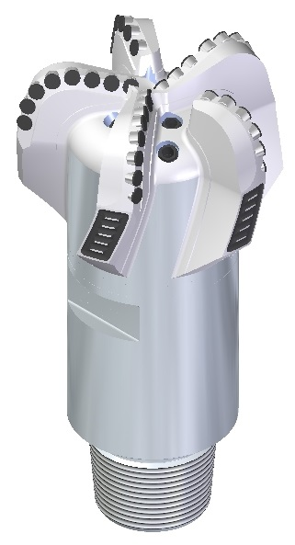

Drill Bit Specifications:
Cutter Size (Primary, Gage) | 3/4”,3/4"
Cutter Count (Total, Gage) | 37, 6
Blade Count | 5
Gage Length (Inches) | 3.00
Nozzle Count (Primary, Sec.) | 7
Nozzle Size (Primary, Sec.) | 60
JSA (Sq. Inches) | 47.55
Max. TFA (Sq. Inches) | 2.60
Operating Parameters:
Hydraulic Flow Rate (Max) | 810
Max. Weight on Bit (1,000 Lbs.) | 39
Make-up Torque (ft/lbs) | 42,677
Nominal Dimensions:
Overall Length (Inches) | 23.875
Make Up Length (Inches) | 19.000
Bit Breaker | SKB-21011
Connection | Ø6-5/8" API Reg.
Approx. Weight (Lbs.) | 260

Standard Features:

- Large open face volume assists cuttings removal
- Seven nozzles optimize blade cleaning and cuttings removal
- Premium grade cutters maximize ROP and Life

519-SR7 Nomenclature Explained:

- 5 = Number of blades
- 19 = Primary Cutter Size
- SR = Single Row Bit
- 7 = Number of Nozzles

